|  |  |  |  |
| --- | --- | --- | --- |
| Name:  Teacher : | ____________________________________  ______________________ | | Date:_________ |
|  | **Year 12 Essentials**  /  **Measurement**  **Full working out MUST be shown to get full marks for each question.** | | |
| **Total Time:** | 30 minutes |  | |
| **Weighting:** | 5% |
| **Equipment:** | Pen, pencil, ruler, scientific calculator. | | |

|  |
| --- |
| **Question 1**  8 **marks (2, 2, 2, 2)** |

**]** Find the **area** of these shapes.

**a] b]**

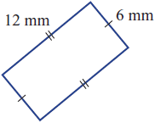 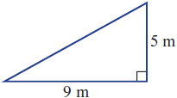

**c] d]**

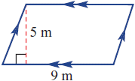 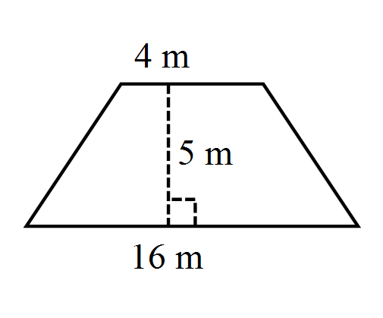

|  |
| --- |
| **Question 2**  6 **marks (3, 3, 3)** |

Find the **circumference** and **area** for this circle. Answer to 2 decimal places.

[4 marks]

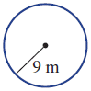

Circumference Area

|  |
| --- |
| **Question 3**  *6* **Marks (3,3)** |

Find the area of these sectors and composite shapes

**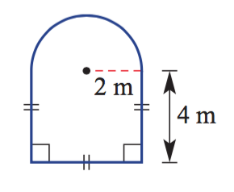 a**

|  |
| --- |
| **Question 4**  *7* **Marks (2, 2, 3)** |

Find the **surface area** of each of the following.

1. b]

 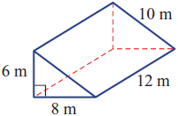

c) Find the **surface area** of each of the following, rounding your answer to 2 decimal places.

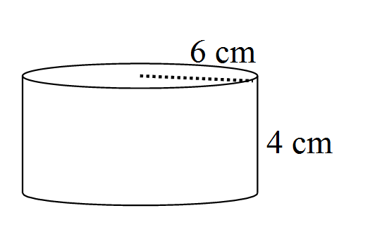

|  |
| --- |
| **Question 5**  *8* **Marks (2, 2, 2, 2)** |

Find the surface area of the following composite shape.

**a)**

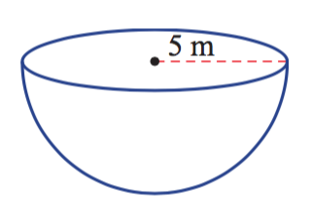

|  |
| --- |
| **Question 6**  *8* **Marks (2, 2, 2, 2)** |

Find the **volume** of the following.

1. b)

 

c) Find the **volume** of the following cylinder, rounding your answer to 2 decimal places.



|  |
| --- |
| **Question 7** *6* **Marks (3,3)** |

a) What is the volume of a cylindrical water tank with a radius 12m and height 8m? Round your answer to 2 decimal places.

b) Find the area needed to paint the outside of a cube with side lengths of 3cm

|  |
| --- |
| **Question 8**  *2* **Marks (2)** |

A rectangular prism has a volume of 48m3. It has a width of 2m and a length of 6m. What must its height be?

|  |
| --- |
| **Question 9** *2* **Marks (2)** |

A cylinder has a volume of 339.29cm3 . It has a radius of 6cm. Find the height, to the nearest centimeter

|  |
| --- |
| **Question 10** *2* **Marks (2)** |

1. A wooden chest is made using a half-cylinder lid which is placed on top of a rectangular prism [as shown in the picture]. The chest has a length of 80cm, and the semi-circle has a diameter of 60cm. The height of the rectangular prism is 40cm. Find the total surface area for the chest, leaving your answer in exact form. [5 marks]

